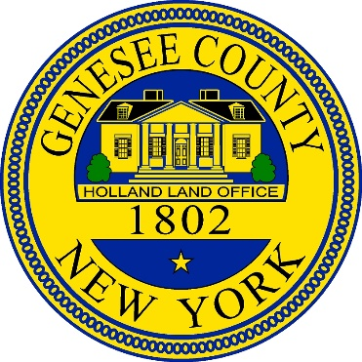

**NOTICE IS HEREBY GIVEN**, That there has been introduced before the Legislature of the County of Genesee, New York, A Local Law Introductory C, of the Year 2023 entitled “A LOCAL LAW AMENDING LOCAL LAW NO. 1 OF THE YEAR 2020, WITH REGARD TO THE IMPOSITION OF A MORTGAGE RECORDING TAX WITHIN THE COUNTY OF GENESEE **NOTICE IS FURTHER GIVEN,** that the Genesee County Legislature will conduct a Public Hearing on proposed Local Law Introductory C, of the Year 2023 on the 28th day of June, 2023 at 5:30 pm at the Old Court House at 7 Main Street, Batavia, New York in the Legislative Chambers. Further information and access to a copy of said proposed Local Law, may be obtained at the Office of Clerk to the Legislature or by email [lisa.casey@co.genesee.ny.us](mailto:lisa.casey@co.genesee.ny.us). All interested persons will be heard. The hearing location is accessible to persons with disabilities, those with hearing impairments, or those in need of translation from English, please contact the Legislature Clerk at 585-344-2550 ext. 2202, at least one week in advance of the hearing date to allow for necessary arrangements. Lisa Casey, Clerk Genesee Co. Legislature Date: June 15, 2023.