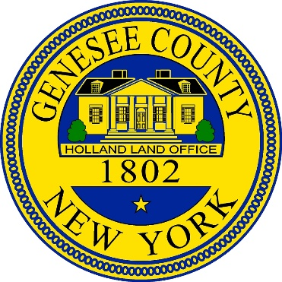

Notice of Public Hearing

Genesee County

Genesee County will hold a public hearing on June 28, 2023 at 5:30pm. at the, Old Court House, 7 Main Street, Batavia, NY 14020 for the purpose of hearing public comments on Genesee County's implementation of the Community Development Block Grant (CDBG) CARES Act grant, project #444CVSB28-21 The CDBG program is administered by the New York State Office of Community Renewal (OCR). The CARES Act provides OCR this funding to support small businesses, improve air quality in public facilities, environmental improvements in housing for safe shelter, conversion of underutilized buildings for affordable housing, and public services. Comments on the CDBG CARES Act program will be received at this time. The hearing is being conducted pursuant to Section 570.486, Subpart I of the CFR and in compliance with the requirements of the Housing and Community Development Act of 1974, as amended.

The Genesee County Legislature Chambers are accessible to persons with disabilities. If special accommodations are needed for persons with disabilities, those with hearing impairments, or those in need of translation from English, those individuals should contact Lisa Casey at (585)-344-2550 ext. 2202, at least one week in advance of the hearing date to allow for necessary arrangements. Written comments may also be submitted to Lisa Casey, Old Court House, 7 Main Street, Batavia, NY 14020 until 5:00pm, June 26, 2023.